Product Line Profitability & Margin Performance Analysis for Nassau Candy Distributor

By MANAN GUPTA

Abstract

For distributors like Nassau Candy, sales volume alone is misleading. Some products sell in high volume but generate low profit, consume disproportionate manufacturing or operational cost, appear successful but weaken overall margins. To remain competitive, the company must understand which products truly drive profit, which divisions underperform financially and where pricing, sourcing, or product rationalization is needed. Currently, the organization lacks visibility into which product lines deliver the highest gross margin, whether high-sales products are actually profitable, how profitability varies across product divisions, which products represent margin risk. This project establishes a clear, data-driven understanding of shipping route efficiency for Nassau Candy Distributor. By transforming raw order and shipment data into route-level operational intelligence, the organization gains actionable insights to improve logistics performance, reduce delays, and enhance nationwide delivery reliability
In this project the author has combined various tools like VS code, Python, Plotly, Pandas and Streamlit to get the desired outcome. Streamlit was integrated with the analytical dashboard to provide an interactive interface for monitoring product profitability, gross margins, regional performance, and operational insights.

INTRODUCTION
Background of the Business Problem
Sales ≠ Profit.
In distribution-based businesses such as candy and confectionery distribution, high sales volume does not always guarantee strong financial performance. Companies often focus heavily on increasing sales revenue, assuming that products with the highest sales contribute the most to business success. However, many products may generate large revenues while producing very low profit margins due to high manufacturing, transportation, storage, or operational costs. As a result, the company may experience strong sales performance but weak overall profitability.

Why Profitability Analysis Matters
Profitability analysis is essential because it helps organizations identify which products, categories, customers, or regions contribute positively to overall business performance. Unlike sales analysis, profitability analysis considers both revenue and associated costs, providing a clearer understanding of financial health.
By conducting profitability and margin analysis, companies can:
- Identify high-profit and low-profit products
- Improve pricing and discount strategies
- Reduce operational inefficiencies
- Optimize inventory and supply chain management
- Focus on products that maximize business value
- Support strategic decision-making and resource allocation

PROBLEM STATEMENT
Currently the organization lacks visibility into
- Which product lines deliver the highest gross margin
- Whether high-sales products are actually profitable
- How profitability varies across product divisions
- Which products represent margin risk

Without this insight, decisions on pricing, promotions, and product portfolio remain reactive and
intuition-based. High sales volume products may generate low profit margins, reducing overall
business profitability. Operational costs significantly affect overall profitability. Even when sales
are strong, excessive operational expenses can reduce net earnings and weaken business
performance.
OBJECTIVES OF THE STUDY:
The primary objective of this study is to analyze product line profitability and margin performance
for Nassau Candy Distributor using data analytics and interactive visualization techniques.
- To evaluate product-wise profitability
- To examine gross profit margin performance
- To identify high-performing and low-performing product lines
- To analyze the relationship between sales and profit
- To assess operational and cost-related impacts on profitability
- To develop interactive dashboards using Streamlit
- To support data-driven business decisions
DATASET DESCRIPTION:
The dataset contains 10194 rows and 18 columns. It is an excel file. Out of the 18 columns, there
are 12 columns with string type data, 3 columns with float and int type data each.
1. Row ID - Unique Row Identifier
2. Order ID - Unique Order Identifier
3. Order Date - Date of order
4. Ship Date - Date of shipment
5. Ship Mode - Shipping method of order
6. Customer ID - Unique customer identifier
7. Country/Region - Country or region of customer
8. City - City of customer
9. State/Province - State/province of customer
10. Postal Code - Postal code / zip code of customer
11. Division - Product division
12. Region - Region of customer
13. Product ID - Unique product identifier
14. Product Name - Product long name.
15. Sales - Total sales value of order
16. Units - Total units of order
17. Gross Profit - Gross profit of order (Sales - Cost)
18. Cost - Cost to manufacture
The above table explains the columns and the data they contain.
The important fields are:
Order Date, Country/Region, City, Division, Product Name, Sales, Units, Gross Profit, Cost.
In the processing done in VS code, the author has
- Handled missing values.
- Filtered data by date.
- Filtered data by Products.
- Filtered data by Division.
- Added fields like Gross Margin %, Profit per unit, Revenue Contribution, Profit Contribution to both filtered by products and by division file.
TOOLS AND TECHNOLOGY USED:
Tool | Purpose
Python | Data analysis
Pandas | Data manipulation
Plotly | Visualization
Streamlit | Dashboard development
Excel | Data source
GitHub | Version control

METHODOLOGY:
Step 1: DATA COLLECTION
The data is provided in csv/excel sheet format.
Step 2: DATA CLEANING
- Handling null values
- Formatting dates
- Removing duplicates
The above is done in VS code, jupyter notebook, python language using pandas and other libraries.
Step 3: DATA TRANSFORMATION
In addition to the 18 columns, after filtering the data by products and division some KPI’s (KEY
PERFORMANCE INDICATORS) are also calculated and added.
They are 1: GROSS MARGIN (%) = GROSS PROFIT / SALES
2: Profit Per Unit = GROSS PROFIT / UNITS
3: Revenue Contribution = Product Sales / Total Sales
4: Profit Contribution = Product Profit / Total Profit
Product Name | Division | Cost | Sales | Units | Gross Profit | Gross Margin % | Profit Per Unit | Revenue Contribution | Profit contribution
Everlasting Gobstopper | Sugar | 26 | 130 | 13 | 104 | 80 | 8 | 0.09 | 0.11
Fizzy Lifting Drinks | Sugar | 31.5 | 78.75 | 21 | 47.25 | 60 | 2.25 | 0.06 | 0.05
Fun Dip | Sugar | 7.2 | 12 | 8 | 4.8 | 40 | 0.6 | 0.01 | 0.01
Hair Toffee | Sugar | 17 | 76.5 | 17 | 59.5 | 77.78 | 3.5 | 0.05 | 0.06
Kazookles | Other | 1113 | 1205.75 | 371 | 92.75 | 7.69 | 0.25 | 0.85 | 0.1
Laffy Taffy | Sugar | 20.25 | 53.73 | 27 | 33.48 | 62.31 | 1.24 | 0.04 | 0.04
Lickable Wallpaper | Other | 3930 | 7860 | 393 | 3930 | 50 | 10 | 5.54 | 4.21
Nerds | Sugar | 8 | 15 | 10 | 7 | 46.67 | 0.7 | 0.01 | 0.01
SweeTARTS | Sugar | 32.8 | 61.5 | 41 | 28.7 | 46.67 | 0.7 | 0.04 | 0.03
Wonka Bar - Fudge Mallows | Chocolate | 8296.8 | 24890.4 | 6914 | 16593.6 | 66.67 | 2.4 | 17.56 | 17.76
Wonka Bar - Milk Chocolate | Chocolate | 9424.38 | 26867.75 | 8267 | 17443.37 | 64.92 | 2.11 | 18.95 | 18.67
Wonka Bar - Nutty Crunch Surprise | Chocolate | 6755 | 23574.95 | 6755 | 16819.95 | 71.35 | 2.49 | 16.63 | 18
Wonka Bar - Triple Dazzle Caramel | Chocolate | 9874.8 | 28485 | 7596 | 18610.2 | 65.33 | 2.45 | 20.09 | 19.92
Wonka Bar -Scrumdiddlyumptious | Chocolate | 8517.3 | 27874.8 | 7743 | 19357.5 | 69.44 | 2.5 | 19.66 | 20.72
Wonka Gum | Other | 286.8 | 597.5 | 478 | 310.7 | 52 | 0.65 | 0.42 | 0.33
VISUALIZATION:

The above table is EDA and cleaning done on the raw dataset. It contains KPI’s grouped by
subcategory Products.
There are 15 Products under 3 Divisions (Chocolate, Sugar, Other). The below table is KPI’s
grouped by subcategory Division.
Division | Cost | Sales | Units | Gross Profit | Gross Margin % | Profit Per Unit | Revenue Contribution | Profit contribution
Chocolate | 42868.28 | 131692.9 | 37275 | 88824.62 | 67.45 | 238.3 | 92.88 | 95.06
Other | 5329.8 | 9663.25 | 1242 | 4333.45 | 44.84 | 348.91 | 6.82 | 4.64
Sugar | 142.75 | 427.48 | 137 | 284.73 | 66.61 | 207.83 | 0.3 | 0.3

DASHBOARD OVERVIEW:
The dashboard is attached with the submitted file. URL is

The dashboard is equipped with 5 filters. 1st filter is Division filter, 2nd is Product filter, 3rd is
date filter (valid date range is 03-01-2024 to 31-12-2025), 4th and 5th are margin % filters
based on minimum and maximum values of margin%.
PRODUCT PROFITABILITY ANALYSIS:
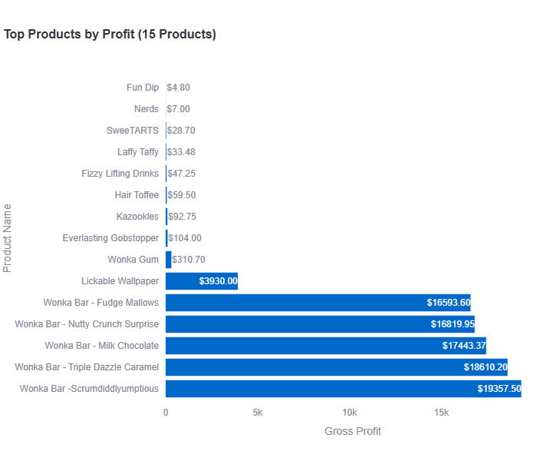
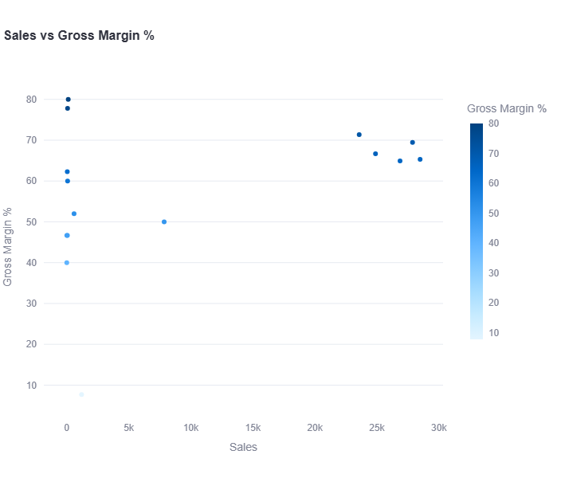
The first graph shows Product Name vs Gross Profit. It is a horizontal BAR Chart. It is clear from the graph Fun Dip is least profitable and Wonka Bar -Scrumdiddlyumptious is most profitable.
The second graph under this category is Sales vs Gross Margin %. It is a SCATTERPLOT.

DIVISION PERFORMANCE ANALYSIS:
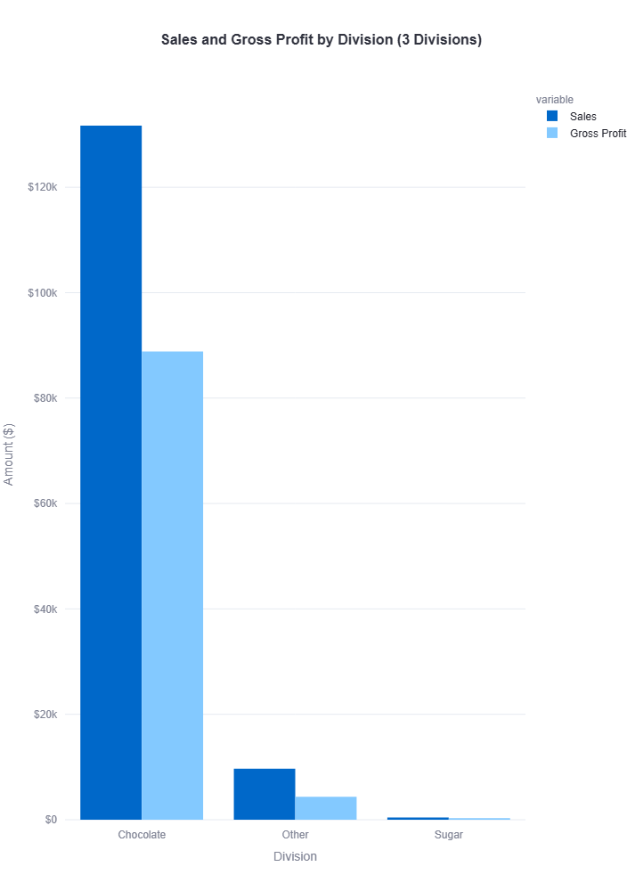
The first graph under Division Performance Analysis gives Sales and Gross Profit by Division. It is a vertical combined BAR chart. It shows Chocolate Division is far more profitable than other divisions.
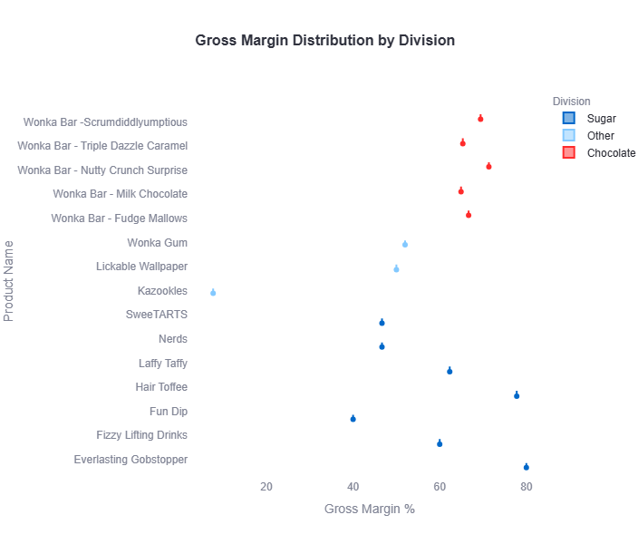 The second graph is Gross Margin % by Division against the Product Names. The graph is SCATTERPLOT.

PARETO ANALYSIS:
Pareto Analysis is a statistical and decision-making technique based on the 80/20 principle, which states that approximately 80% of outcomes are often generated by 20% of causes. In business analytics, Pareto Analysis helps identify the small number of products, customers, or categories that contribute the most to overall profit, sales, or operational impact.
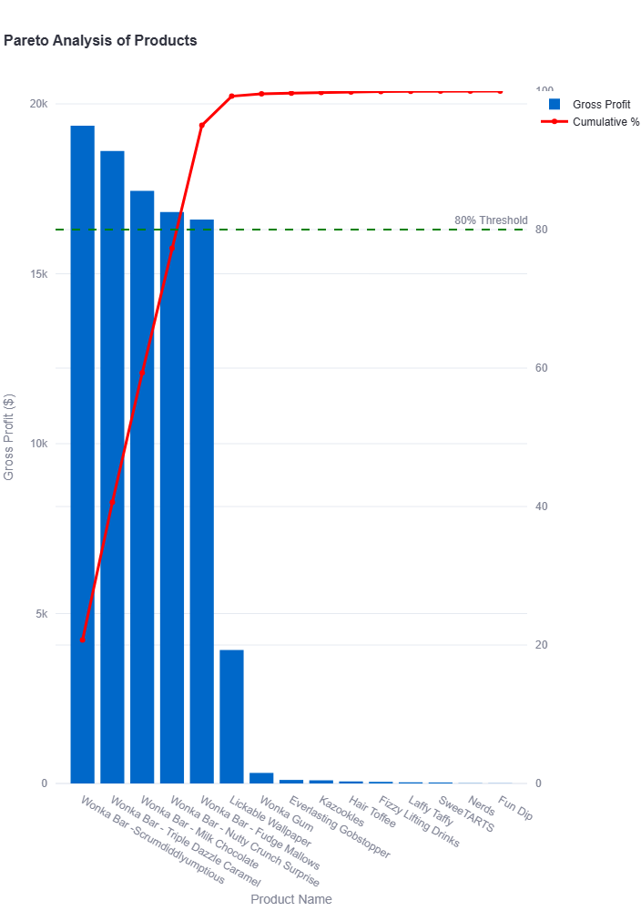
From the graph it is clear that 4-5 products out of the 15 products makes about more than 95% of the profit.

COST STRUCTURE DIAGNOSTICS:
The graph shows Cost vs Sales with Gross margin %. It is a SCATTERPLOT.
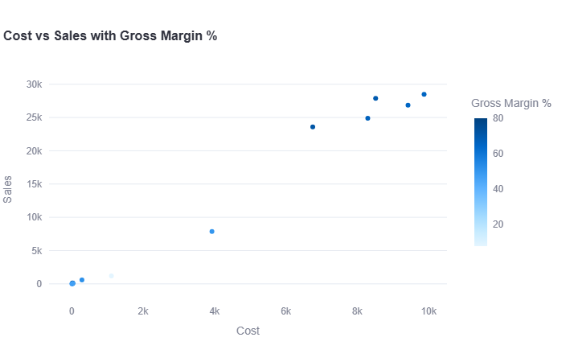

FACTORY LOCATION AND ORDER VOLUME ANALYSIS:
There are total 5 factories. A HEATMAP is shown indicating the volume of orders by size of ball at each factory coordinates.
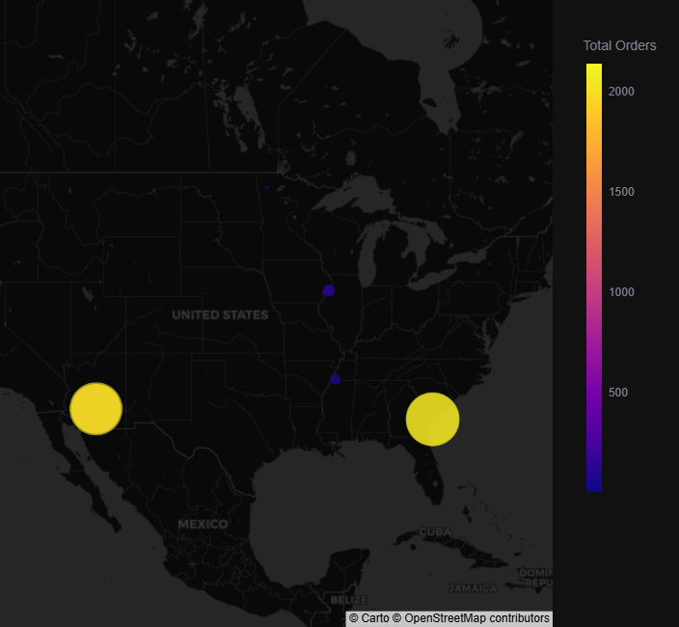
KEY FINDINGS / INSIGHTS / RECOMMENADTIONS:
- The CHOCOLATE division has the most sales and most profit.
- There are 5 candy’s which make majority of profit and sales.
- The company Sugar Shack has few orders compared to other companies. The company workload maybe diverted to other companies.
- Some candies like Fun Dip and NERDS may be discontinued due to low profit.

CHALLENGES FACED:
During the development of the Product Line Profitability & Margin Performance Analysis Dashboard, several technical and business-related challenges were encountered. These challenges required careful data handling, debugging, and optimization to ensure accurate analysis and smooth dashboard performance.

1. Data Inconsistencies and Data Cleaning:
One of the major challenges involved inconsistencies within the dataset, including missing values, duplicate records, inconsistent formatting, and incorrect data types.

2. Streamlit Multipage Navigation Issues:
While developing the interactive dashboard using Streamlit, difficulties were encountered in configuring multipage navigation and connecting different dashboard pages properly. File path errors, page recognition issues, and page-switching functionality required debugging and restructuring of the project directory.

3. Visualization Formatting and Dashboard Design

Designing clear and interactive visualizations posed challenges in terms of layout alignment, chart readability, labeling, and responsiveness. Certain visualizations, such as Pareto charts and geographical mapping, required additional customization to improve interpretability and presentation quality.

CONCLUSION:
The study concluded that sales revenue alone is not a reliable indicator of business success, as
high sales do not always result in high profitability. Several products generated strong sales
volumes but contributed lower profit margins due to operational costs, discounts, and other
business expenses. Therefore, profitability and margin analysis are essential for identifying
products that truly contribute to the company’s financial performance and long-
sustainability.
The project also demonstrated the effective use of Streamlit in developing an interactive
analytical dashboard for business intelligence and data visualization. The dashboard enabled
efficient monitoring of product profitability, margin trends, and regional performance through
dynamic charts and KPI metrics. This integration supported data-driven decision-making and
improved the overall accessibility and interpretation of complex business data.

REFERENCES:
Useful references:
- Python Documentation
- Pandas Documentation
- Plotly Documentation
- Streamlit Documentation
- GitHub

